|  |  |
| --- | --- |
| PROJECT REPORT  ON  CAR BUYING AND SELLING WEBSITE | HTML REPORT  SUBMITTED TO :-  MANU BALI MAM  SUBMITTED BY:-  riya-(11910138) rol no:31  kuldeep-  (11910165) rol no:32  pavneet pal singh-(11601740) rol no:32  section :- k19hz |
| 1 |  |

Outline:-

1. Introduction
2. Goals And Objectives
3. Existing System
4. Some innovative features in new system
5. Schedule of our project
6. Used Software Model
7. Used Technology
8. Hardware And Software Requirements
9. Key Features
10. Modules
11. Function Of System
12. Data Modeling
13. Functional & Behavioural Modeling

INTRODUCTION

* Car Trading means buy/sell used cars including budget, model, prices, company etc.
* Our project is meant to give people a better and trustworthy platform where they can sell and buy cars of their own choice and obviously on their own terms and condition.
* With the help of internet and computer systems a man from remote area can buy/sell his car from anywhere the country/world.
* We can also add option of the online auction of heritage and vintage cars in which customers can take part in the auction. This will eliminate the barrier of distance and area.

Goals And Objectives

* The main purpose of “car trading portal” is sell/buy used/second-hand cars online. Using this project anyone can buy/sell used cars online including by budget, cities, model, company etc.
* This project would become the best market place and information source on old cars bought and sold in India. In this project, we want to make the some modules like car seller module, car buyer module, find cars including budget, car comparisons etc.
* This project will provide facility to all buyer, seller and dealers for buy/sell cars. If anyone want to buy used cars online, then first he will register in this website and then he can see all the details about the sell used cars including prices, model and cities.

Cont…

* It provides the best used cars for the cheapest prices, creating more value for costumer visiting.
* It provides the message of new dealing cars, used cars to the visitor who register in the website.
* This system is based on the buyer budget, seller budget for the buying/selling used cars. The main goal is to provide easy way for buying and selling used cars online.
* Any person can register in the website and after that he can buy used cars, sell used cars, compare the cars regarding budget, model, company, city

Existing System:-

* In the existing system, the registered users and unregistered users can buy/sell use cars with some searching criteria like color, company.
* In this system, if the visitors can visit the website once then message will not be going in their mobile/email by the existing system.
* The existing system is paid and in this system commission is taken for buying/selling used cars.

Some Innovative Features In New System

* In our new system, buyers and sellers can search used cars with many criteria like company, budget, color, model, city, year etc.
* In our system, we want to add new module as a comparison cars with company and budget.
* In our new system searchingcriteria will be strong with year, budget etc.
* The new feature of our system will messages. In this module, Visitor can visit in our website once, when the new used car will deal in the system, message/mail will be passed in their messages.

Used Software Models:-

3D printing allows for more efficient **car** **model** design, prototyping, testing and production using industrial 3D printing software.



This software enables designers to create printable designs which are the first crucial step in creating 3D printed **automobile** parts, and the core of printing process.

Software for 3D Printing in the Automotive Industry:-

3D printing allows for more efficient car model design, prototyping, testing and production using industrial 3D printing software. This software enables designers to create printable designs which are the first crucial step in creating 3D printed automobile parts, and the core of the printing process.

To use all the capabilities of a 3D printer, you need to have 3D printer control software and 3D editors that allow the equipment to perform specific tasks. All the software must comply with certain standards, i.e. it must “grasp” various formats of necessary data input.

As a rule 3D printer software uses :-

. STL language (to describe the surface of the set model triangles are used)

· X3D language (the count starts from the preset profile, it is built on XML standard)

· VRML standard (based on triangles that do not have common points.



Used Technology

* FRONT END
* ASP.Net With C#
* BACK END
* MS SQL Server

TOOLS

* CSS (CasCading Style Sheet)
* Javascript

HARDWARE AND SOFTWARE REQUIREMENTS:-

* HARDWARE REQUIREMENTS
* Processor
* Memory
* Disk Drive
* Printer
* Modem
* Screen
* Secondary Hard Disk
* Network Card

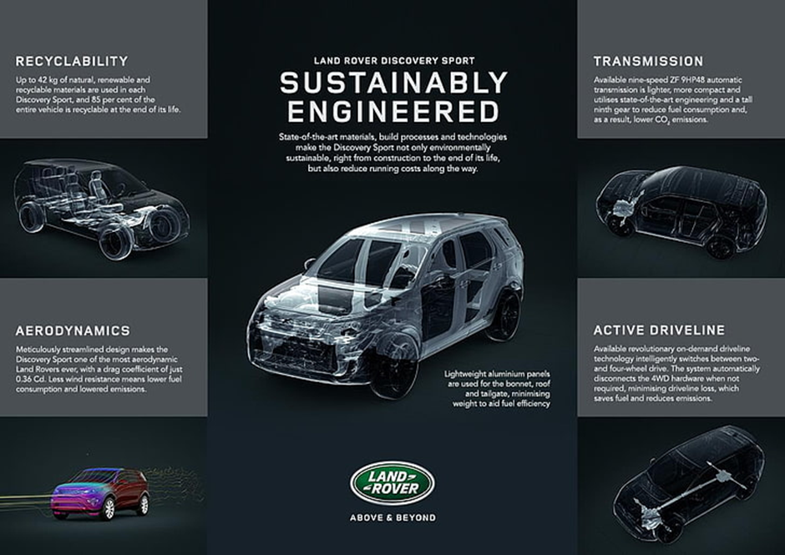

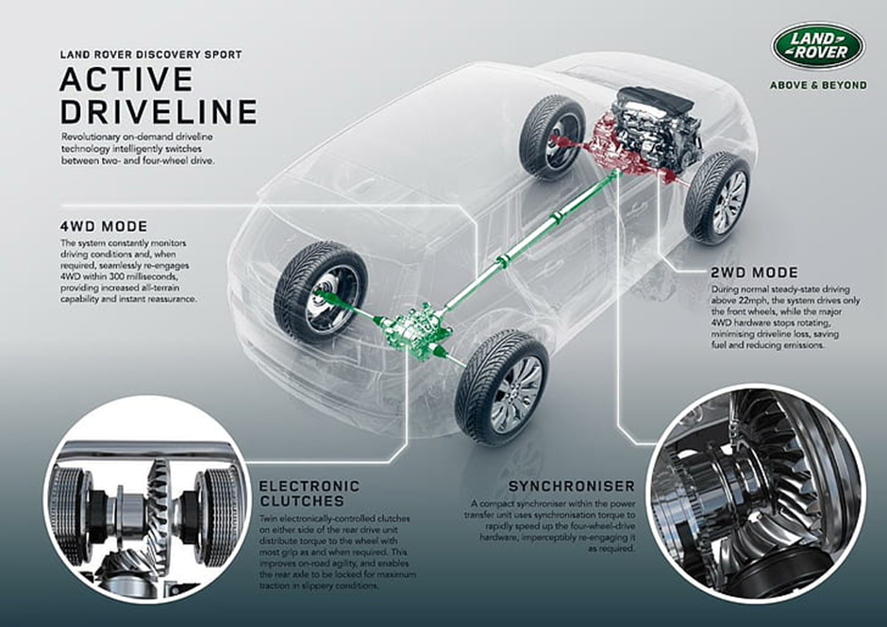

Cont…

* SOFTWARE REQUIREMENTS
* Windows 32-bit operating system (Windows 7,

Windows XP)

* .NET Framework
* Microsoft SQL server
* Microsoft Visual Studio

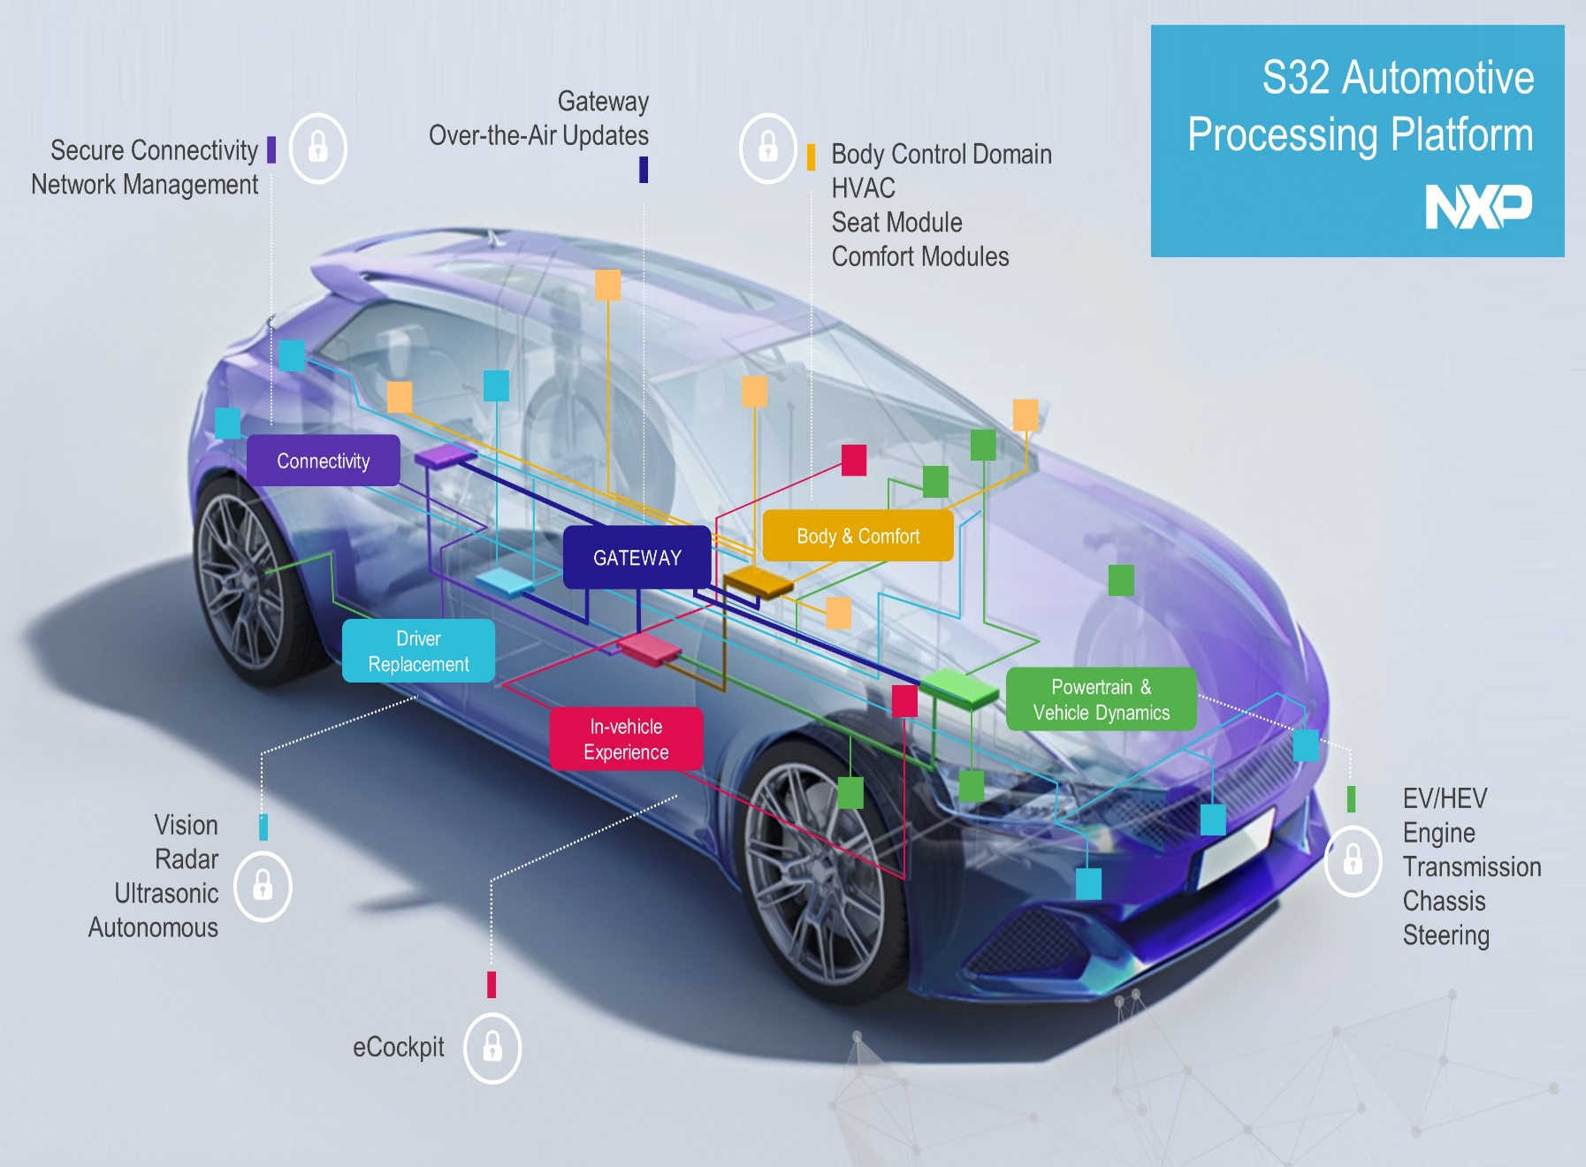

Key Features

* Best Trading Process.
* Huge Saving.
* Free of cost registration in the website.
* High privacy of buyer,seller and visitor details.
* Data and records can be easily retrieved.
* Commision is not required in buying/selling used cars.

Modules

* Login module
* Admin module
* Buy used car module
* Sell used car module
* Search module
* Compare cars module
* Manage Buyers/Sellers module for admin only
* FAQ module
* Post Comments module

Function Of System

* Usecase diagram

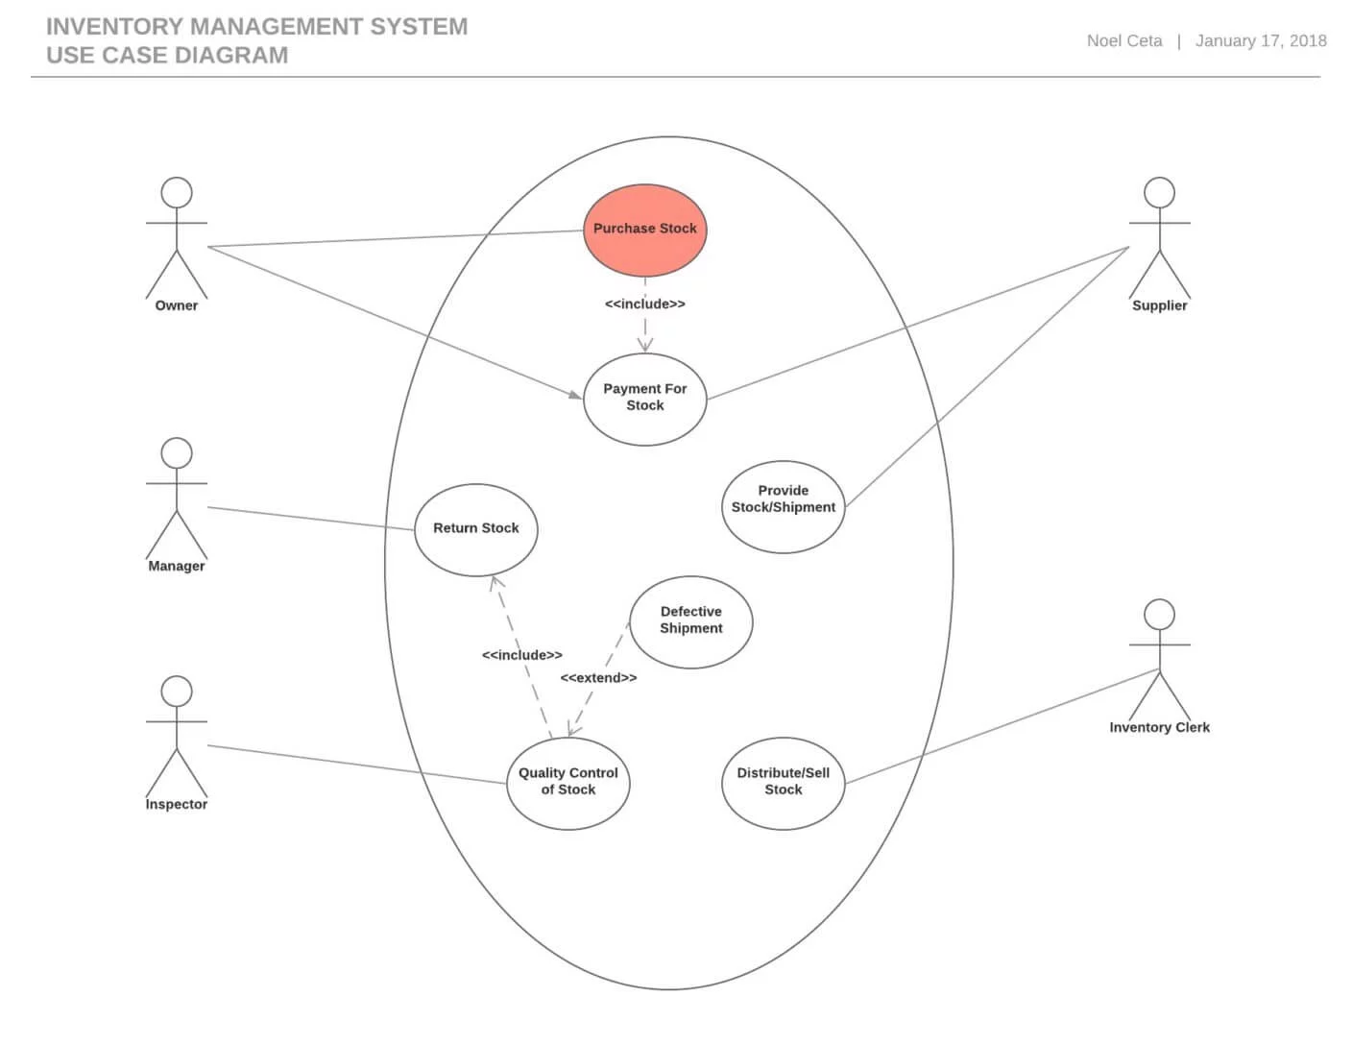

Data Modelling

* Class Diagram
* 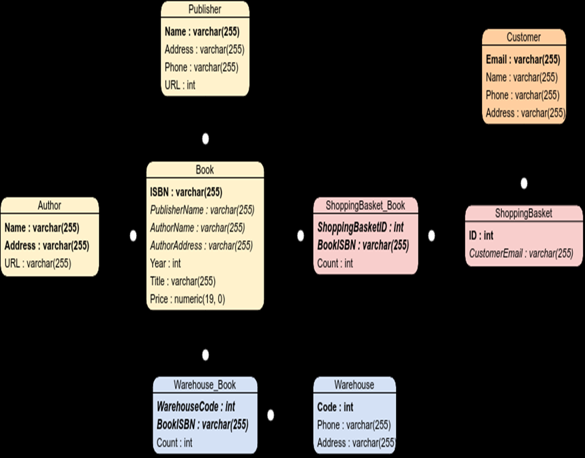

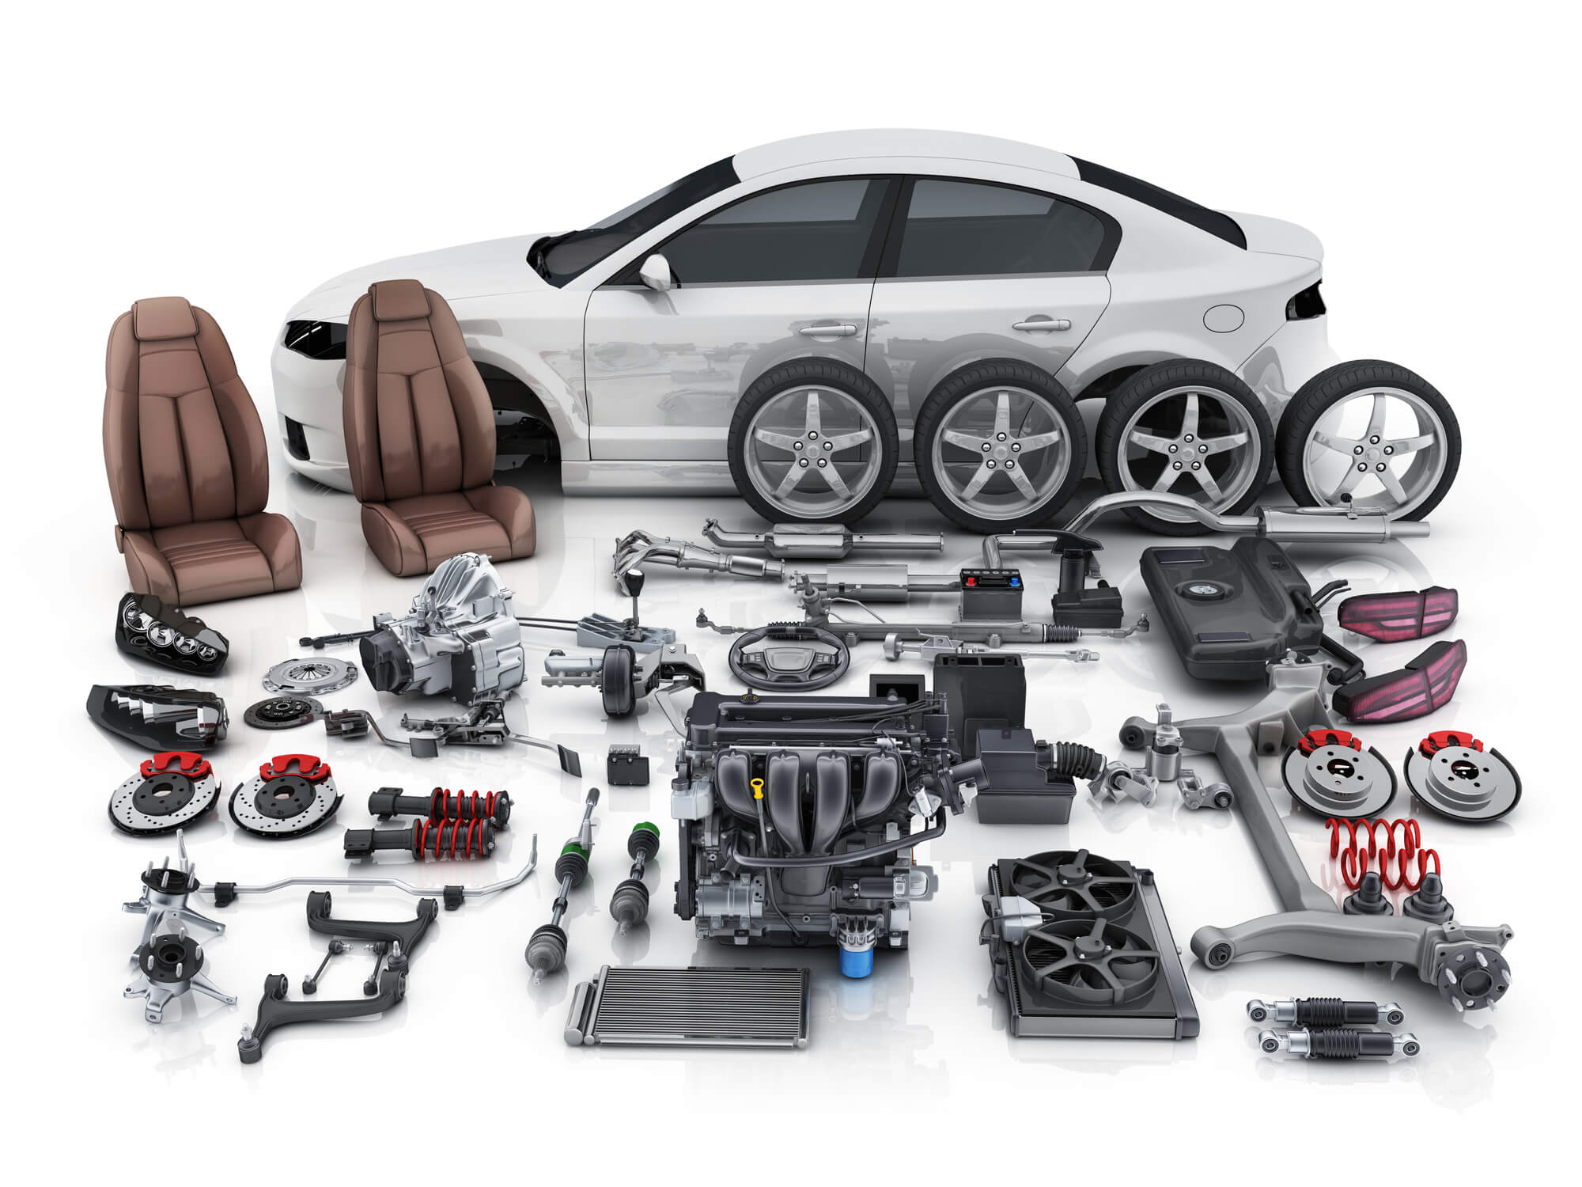

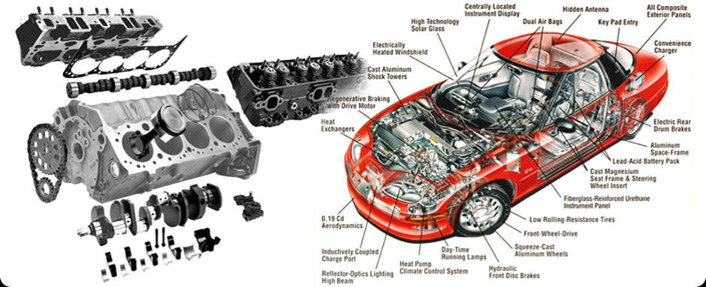

Functional And Behavioural Modelling

